Private Members and Inheritance — Deep & Practical Explanation

🔹 What does “private members do NOT participate in inheritance” really mean?
Meaning in simple words
When a class has private variables or methods:
- Child class does NOT receive them
- Child class cannot see them
- Child class cannot directly use them
Even though the child object contains them in memory,
they are not accessible to the child class code.

Example
class A111 {
private String name = "pavan";
}
Now:
class A112 extends A111 {
}
❌ A112 does NOT inherit the variable name
❌ You cannot write name inside A112
class A112 extends A111 {
void disp() {
// System.out.println(name); // ❌ Compile-time error
}
}
✔️ This rule exists to protect data

🔹 Why Java does this? (Encapsulation reason)
Encapsulation means:
Internal data should not be directly modified from outside
If Java allowed private members in child classes:
- Child classes could freely change internal state
- That would break data safety
- That would defeat encapsulation
So Java strictly says:
private = class-only access

🔹 How access is allowed correctly (Getter / Setter)
class A111 {
private String name = "pavan";

public void setName(String name) {
this.name = name;
}

public String getName() {
return name;
}
}
What is happening here?
- name → private (hidden)
- setName() → controlled modification
- getName() → controlled read access
This keeps:
✔️ Data safe
✔️ Validation possible
✔️ Logic centralized

Child class usage (correct)
class A112 extends A111 {
public void disp() {
setName("pavan"); // allowed
System.out.println(getName()); // allowed
}
}
Why this works
- Child inherits public methods
- Child does not inherit private data
- Parent controls how data is accessed

Output class
public class Inheritance_Private {
public static void main(String[] args) {
A112 obj = new A112();
obj.disp();
}
}

Eg: Inheritance_Private_Data_Members

✅ Important Practical Understanding (Very Important)
The object contains private data
The child class code cannot access it directly
Inheritance is about access, not memory existence.

Private methods are NOT accessed in the child class — at all.
❌ Not directly
❌ Not via super
❌ Not via override
❌ Not even via getters/setters
👉 Private methods can be executed only by the parent class itself.

🔹 Why private variables can be “used” but private methods cannot
This is the key mental model 👇
Member type | How child interacts
Private variable | Indirectly (via public/protected methods)
Private method | Cannot interact at all
Why?
Because methods are behavior, not data.

🔹 Private Method Rule (Must Remember)
Private methods do NOT participate in inheritance in any form.
That means:
- Child does not inherit them
- Child cannot see them
- Child cannot call them
- Child cannot override them

🔹 Example 1: Private method in parent
class A111 {
private void secretLogic() {
System.out.println("Secret logic");
}
}
Child class:
class A112 extends A111 {
void disp() {
// secretLogic(); // ❌ Compile-time error
}
}
❌ This is ILLEGAL

🔹 Then how are private methods ever used?
👉 Private methods are helper methods
👉 They are used inside the same class only
Parent controls execution
class A111 {

private void secretLogic() {
System.out.println("Secret logic");
}

public void execute() {
secretLogic(); // ✅ allowed
}
}
Child:
class A112 extends A111 {
void disp() {
execute(); // ✅ allowed
}
}
What is happening here?
- A112 calls execute() (public)
- execute() internally calls secretLogic() (private)
- Child never touches the private method
✔️ Encapsulation preserved
✔️ Control remains with parent

🔹 Important Line (Read Twice)
Child class does NOT call private methods — parent class calls them on behalf of the child.

But in Java design terminology, this is described as:
Controlled access to private behavior via a public/protected method
or informally:
Delegation to private methods

🔹 Can a child override a private method?
❌ NO — never
Example:
class A111 {
private void show() {
System.out.println("Parent");
}
}

class A112 extends A111 {
private void show() {
System.out.println("Child");
}
}
⚠️ This is NOT overriding
Why?
- Parent’s show() is invisible to child
- Child’s show() is a new, unrelated method
This is called:
Method hiding by coincidence (not polymorphism)

🔹 Proof: No polymorphism
A111 obj = new A112();
obj.show(); // ❌ Compilation error (method not visible)
Private methods:
- No inheritance
- No overriding
- No runtime polymorphism

🔹 Why Java enforces this (Design Reason)
If private methods were accessible:
- Child could change internal algorithm
- Parent behavior could break
- Encapsulation would be destroyed
So Java says:
Private behavior is class-only behavior

🔹 Industry Pattern (Real Projects)
✔️ Correct design
class PaymentService {

public void processPayment() {
validate();
deductAmount();
logTransaction();
}

private void validate() { }
private void deductAmount() { }
private void logTransaction() { }
}
Child class:
class UpiPaymentService extends PaymentService {
// cannot touch internal steps
}
✔️ Stable
✔️ Safe
✔️ Maintainable

🔹 Final Golden Summary (Very Important)
- Private variables
  - Exist in object
  - Accessed indirectly via methods
- Private methods
  - Exist in class only
  - Executed only by parent class
  - NEVER accessed by child class
Child class uses private methods only through public/protected parent methods — never directly.

Not recommended just for knowledge
👉 Private methods cannot be accessed by inheritance, but they can be accessed or modified at runtime using the Reflection API.

Things needed to use Reflection API
1️⃣ Object of the class
2️⃣ Class object (Class<?>)
3️⃣ java.lang.reflect.Method
4️⃣ Method name as String
5️⃣ setAccessible(true) to bypass access check

Eg: Private_Method_Inheritance

Class<?> means the class type is unknown at compile time but will be known at runtime, and the variable can hold any class metadata.

What is really happening (simple words)
- Child class does NOT inherit the private method
- Reflection bypasses Java access rules at runtime
- JVM is forced to execute the private method
- This is not inheritance, it is forced access

Can we modify private methods?
👉 We cannot change method body,
but we can:
- invoke it
- access it
- bypass visibility rules
(Method body change requires bytecode tools, not reflection)

Important notes (must remember)
- ❌ Not compile-time safe
- ❌ Breaks encapsulation
- ❌ Not used in business logic
- ✔️ Used only by frameworks & tools

Constructors are NOT inherited by the child class.
But parent class constructors are executed when a child object is created.
👉 This execution happens because of super(), not because of inheritance.

If constructors were inherited, then creating an object of the parent class would also trigger the child class constructor, because inheritance would allow the parent to “use” the child’s constructor.
But this never happens in Java.
Java strictly follows this rule:
- Parent object → only parent constructor
- Child object → parent constructor + child constructor (via super())
Therefore:
The execution of the parent constructor during child object creation happens only because of the super() call, not because constructors are inherited.
Hence, constructors do not participate in inheritance; they are only used for object initialization, specific to the class whose object is being created.

Eg: Constructor_Working_During_Inheritance_Eg1
// go through the code

Eg : Constructor_Working_During_Inheritance_Eg2

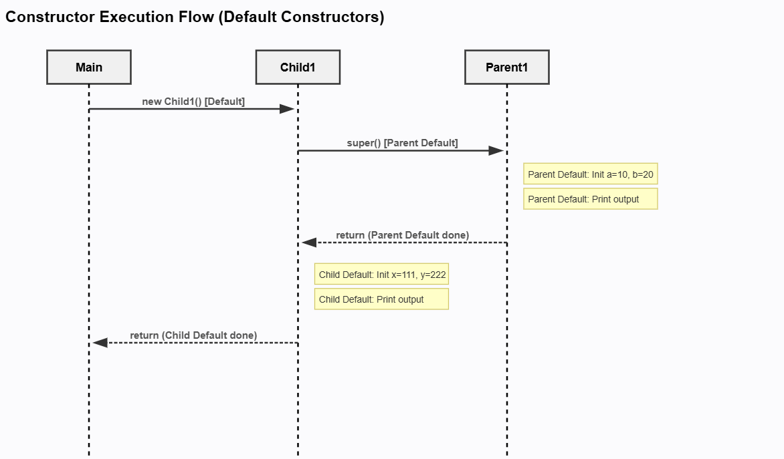

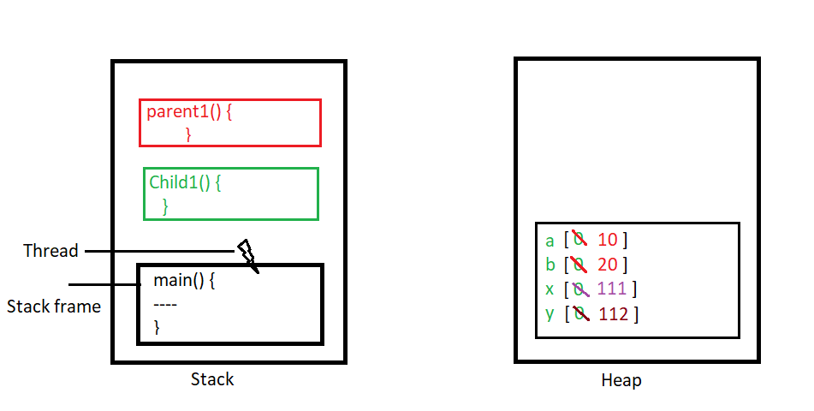

Parameterized constructors are NOT called automatically.
They must be invoked explicitly using super(arguments) or this(arguments).
This code perfectly demonstrates that rule.

🔍 What exactly is happening in your code
When this line executes:
Child1 ref = new Child1();
Step-by-step execution:
- JVM starts creating a Child1 object
- Control goes to Child1() (no-arg constructor)
- Compiler automatically inserts super() as the first statement
- So this is what really executes:
Child1() {
super(); // implicit
System.out.println("this is empty child class constructor");
x = 111;
y = 222;
}
- super() calls:
Parent1()
- Only the no-arg parent constructor executes
- Parameterized parent constructor is NOT called
- Control returns to child constructor
- Child fields are initialized

Eg : Constructor_Working_During_Inheritance_Eg3
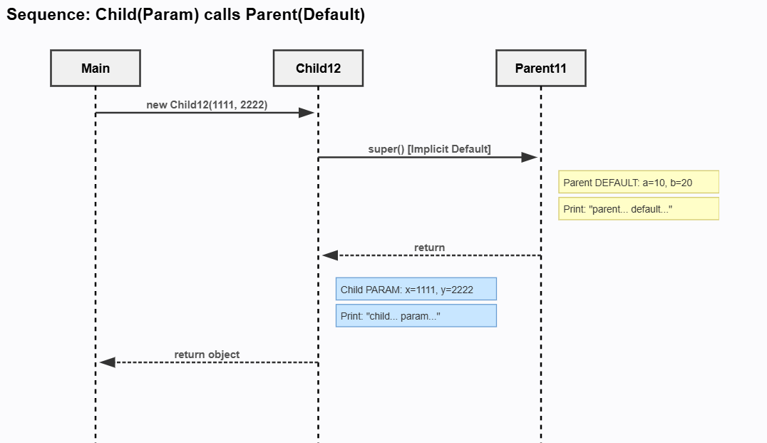
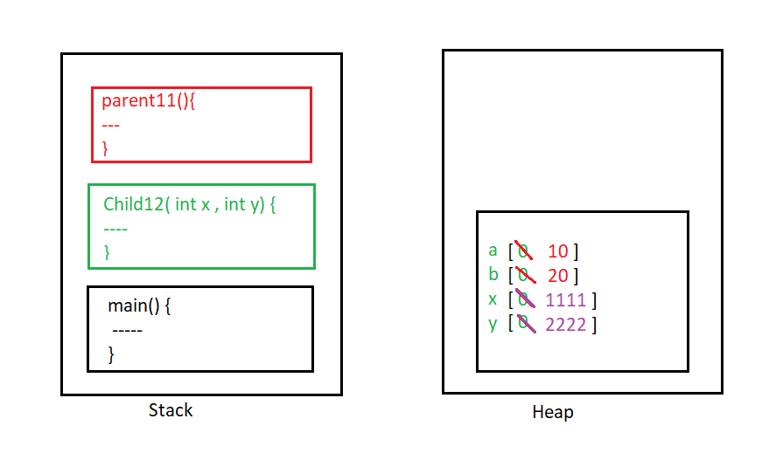

When you explicitly call a parameterized child constructor during object creation:
Child12 ref = new Child12(1111, 2222);
What happens by default:
- Child’s parameterized constructor is selected
  - ❌ Child default (no-arg) constructor is NOT called
  - Java never jumps between constructors automatically
- Inside the child parameterized constructor:
  - Compiler automatically inserts super()
  - So parent default constructor is called
- Parent parameterized constructor is NOT called
  - Java does not guess parameters
  - It must be invoked explicitly using super(args)
- After parent default constructor finishes:
  - Control returns to the child parameterized constructor
  - Child constructor completes execution

❌ What does NOT happen (very important)
- ❌ Child default constructor is not called
- ❌ Parent parameterized constructor is not called
- ❌ Constructors do not chain automatically by type or arguments

✅ Rule summary (golden rules)
- Java calls only ONE constructor per class
- Constructor chaining happens only through explicit calls
- Default behavior:
  - super() → parent no-arg constructor
- Parameterized constructors → manual invocation only

🧠 One-line exam / interview answer
When a parameterized child constructor is explicitly invoked, Java automatically calls only the parent’s no-arg constructor; neither the child’s default constructor nor the parent’s parameterized constructor is called unless explicitly specified.

Eg : Constructor_Working_During_Inheritance_Eg4
